**AI-Driven Exploration and Prediction of Company Registration Trends**

**Phase -2**

**Team member**

**Name : vallarasu.S**

**Dept : CSE-III year,**

**Domain : AI101(IBM-Artificial Group2),**

**NM ID : au622721104O32,**

**Team Name : AI-DRIVEN,**

**College : SRG Engineering College.**

**Introduction:**

This project leverages AI to predict future company registration trends, revolutionizing strategic decision-making. Utilizing advanced AI techniques like ensemble methods and deep learning enhances prediction accuracy, fostering a data-driven approach in understanding registrations.

**Source:**

[**https://tn.data.gov.in/resource/company-master-data-tamil-nadu-upto-28th-february-2019**](https://tn.data.gov.in/resource/company-master-data-tamil-nadu-upto-28th-february-2019)

**Project Model:**

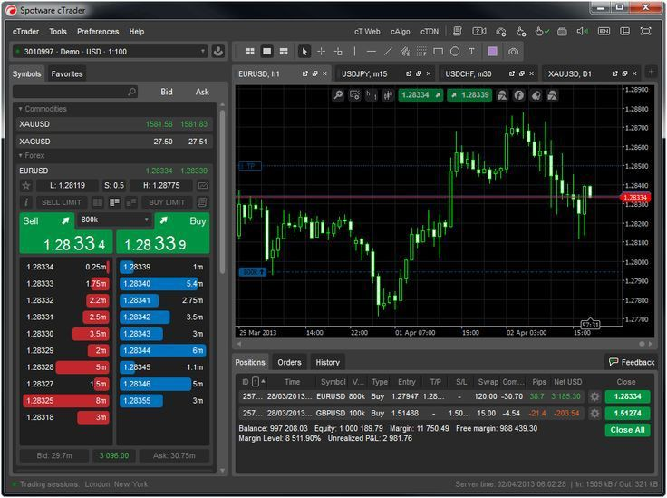

**Motivation:**

The motivation lies in harnessing AI's potential to foresee company registration trends, empowering informed decisions and policy shaping. By enhancing prediction accuracy, we aim to foster a data-driven approach, facilitating sustainable business growth and economic development.

**Training and Fine-Tuning:**

Initially training machine learning or AI models using a portion of the available dataset to learn patterns and make predictions. Fine-tuning follows this, adjusting model parameters based on validation data to improve performance and optimize results before deployment.

**Enhancements and Benefits:**

Improving the project for efficiency and user experience, resulting in increased accuracy and overall success. These improvements amplify the project's impact, making it more effective and valuable for users and stakeholders.

**User Guide:**

We will explain how to effectively utilize the project, navigate its features, and achieve their desired objectives. It serves as a manual, offering step-by-step guidance to enhance user understanding and facilitate optimal utilization of the project.

**Performance Evaluation:**

"Performance Evaluation" involves assessing the efficiency, accuracy, and effectiveness of the project. This assessment is based on predefined metrics and criteria, allowing for a thorough understanding of how well the project meets its objectives and user expectations.

**Future Directions:**

Encompass potential paths or advancements the project can take, including scalability, integration of emerging technologies, and addressing evolving user needs. These future directions aim to enhance the project's relevance, efficiency, and impact in an ever-changing landscape.

**Acknowledgments:**

Express gratitude and recognition to individuals, organizations, or resources that contributed support, guidance, or assistance during the project's development. It acknowledges their valuable contributions and signifies collaborative efforts in achieving project goals.

**Conclusion:**

Summarizes the project's key findings, achievements, and their significance. It provides a concise wrap-up, highlighting the project's impact and the knowledge gained during its development.